Demonstrate Continuous Integration and development using Jenkins.

Steps:

1. Install Jenkins(visit https://www.jenkins.io)

2. Run Jenkins :http://localhost:8080

3. Create new Freestyle Project: CI-Demo

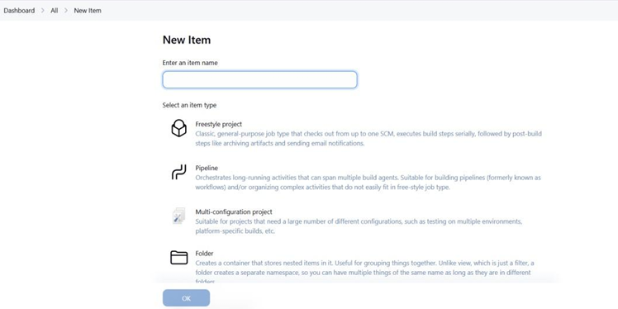

4. Under Source Code Management,choose Git and enter your repo URL.

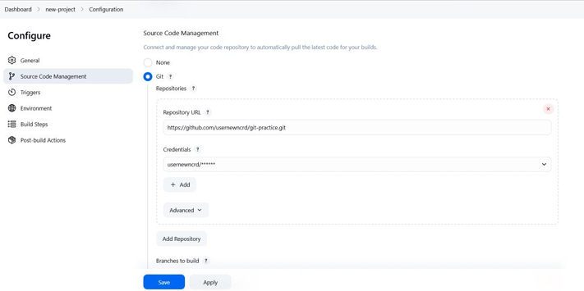

5. Add Build Step>Execute Shell:

echo"Building Project..."

echo"Run tests..."

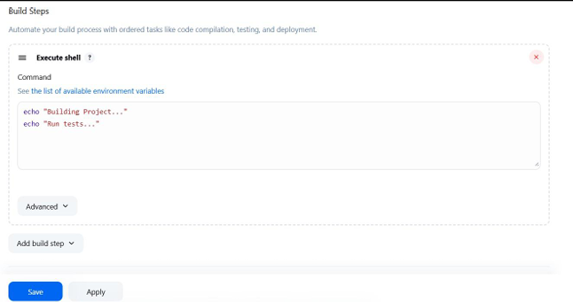

6. Save and click Build Now

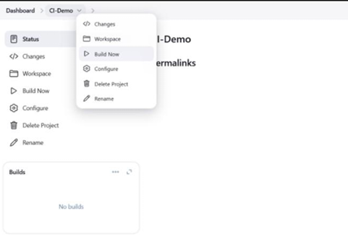

7. Check output in Console Output

